LOOPS

1. Execute the command in the file lab04_1.sql to create the MESSAGES table. Write a
PL/SQL block to insert numbers into the MESSAGES table.
a. Insert the numbers 1 to 10, excluding 6 and 8.
b. Commit before the end of the block.
c. Select from the MESSAGES table to verify that your PL/SQL block worked.

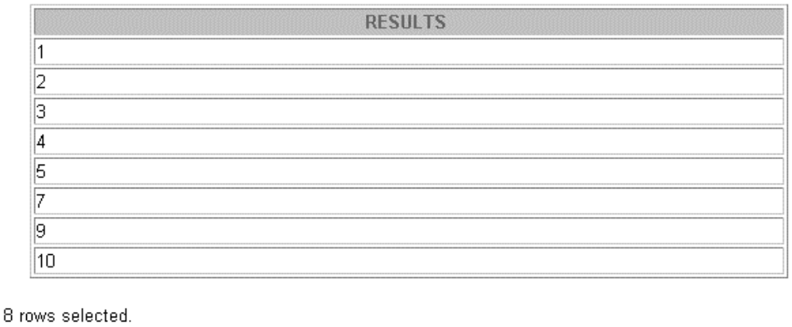

- WRITE A PL/SQL BLOCK OF CODE FOR INVERTING A NUMBER 5639 TO 9365

